Work Breakdown Structure & Project Schedule
Author: Matthew Rushmer, Isaiah Thompson, Rahul Shankar, Bradley Ah Sam
Date: 16/09/2026
Project Name: PMS Comparison (Cloud-Based Project Management Software Review – ECMS Wiki)

This document covers Assignment 1, Part 2, items 15 (Work Breakdown Structure, 20 marks) and 16 (Project Schedule, 20 marks). It builds directly on the Part 1 Business Case (budget $200,000; planning starts 1 Aug 2025; implementation complete 30 Dec 2025; Wiki live 1 Feb 2026) and the Project Charter’s stated Approach: Planning → Designing → Review → Feedback collection → Delivery.

15. Work Breakdown Structure (WBS)

15.1 Method and Rationale
This WBS uses a phase-based, deliverable-oriented decomposition built directly on the five phases already committed to in the Project Charter’s Approach section Planning, Designing, Review, Feedback collection, Delivery broken down into work packages of roughly 1–2 weeks of effort (the PMBOK "8/80 rule" sizing). This keeps Part 2 consistent with Part 1 instead of introducing a second, contradictory structure. Two research work packages (2.4 and 2.5) are sized at three weeks rather than the general one-to-two-week band: researching a full candidate PMS in depth across all five PMBOK process groups is genuinely larger in scope than the other leaf packages, so this is treated as a deliberate, justified exception to the sizing guideline rather than a violation of it.

15.2 WBS Hierarchy
0.0 PMS Comparison Wiki Project
├── 1.0 Planning
│ ├── 1.1 Finalise scope statement, quality goals, WBS & schedule baseline sign-off
│ ├── 1.2 Confirm PMS shortlisting criteria with supervisor
│ └── 1.3 Confirm ECMS infrastructure & Wiki workspace access
├── 2.0 Designing – PMS Research & Evaluation
│ ├── 2.1 Market scan of candidate cloud PMS tools (excl. Microsoft Project)
│ ├── 2.2 Apply shortlisting criteria & finalise the two PMS selections
│ ├── 2.3 Benchmark Microsoft Project’s feature set to derive comparison criteria
│ ├── 2.4 Research PMS A across all five PM process groups
│ ├── 2.5 Research PMS B across all five PM process groups
│ └── 2.6 Compile source list & APA references
├── 3.0 Designing – Wiki Content Development
│ ├── 3.1 Draft Wiki structure & navigation (by process group and by tool)
│ ├── 3.2 Write Initiating process group comparison
│ ├── 3.3 Write Planning process group comparison
│ ├── 3.4 Write Executing process group comparison
│ ├── 3.5 Write Monitoring/Controlling process group comparison
│ ├── 3.6 Write Closing process group comparison
│ └── 3.7 Compile intro/criteria pages & build out Wiki formatting
├── 4.0 Review & Feedback Collection
│ ├── 4.1 Internal team review (accuracy, citations, quality goals)
│ ├── 4.2 Word-count compliance check & trim to ≤4,500 words
│ ├── 4.3 Supervisor/TA review checkpoint
│ └── 4.4 Recruit & collect sample R&D student feedback
└── 5.0 Delivery
├── 5.1 Analyse feedback & revise content
├── 5.2 Final proofread, sign-off & publish Wiki to ECMS servers
├── 5.3 Announce Wiki to R&D coordinators/students
├── 5.4 Handover documentation to ECMS IT
└── 5.5 Milestone report (v2), lessons-learned report & project closure meeting
25 work packages across 5 phases every leaf item is small enough for one team member (or a clear pair) to own, and produces a checkable output.

15.3 WBS Dictionary
WBS # | Work Package | Deliverable / "Done" looks like | Owner
1.1 | Finalise scope, quality goals, WBS & schedule baseline sign-off | Signed-off scope statement (#14) with quality goals stated; this WBS and schedule approved by the team | Whole team, led by Matthew
1.2 | Confirm PMS shortlisting criteria with supervisor | Supervisor-agreed written criteria for shortlisting candidate PMS tools | Matthew
1.3 | Confirm ECMS infrastructure & Wiki workspace access | Confirmed lab/remote access to the Wiki platform for all 4 members | Rahul
2.1 | Market scan of candidate cloud PMS tools | Longlist of ≥5 candidate SaaS PMS tools (Microsoft Project excluded) | Isaiah
2.2 | Apply criteria & finalise 2 PMS selection | Final 2 PMS named, with the criteria-based rationale documented | Whole team, decision led by Matthew
2.3 | Benchmark MS Project feature set | One-page feature map of MS Project across the 5 process groups, used to derive comparison criteria (never listed as a selectable option) | Bradley
2.4 | Research PMS A across 5 process groups | Sourced notes on PMS A’s Initiating/Planning/Executing/Monitoring-Controlling/Closing features | Isaiah & Rahul
2.5 | Research PMS B across 5 process groups | Sourced notes on PMS B’s Initiating/Planning/Executing/Monitoring-Controlling/Closing features | Matthew & Bradley
2.6 | Compile source list & APA references | De-duplicated reference list in APA format, ready to cite in-text | Rahul
3.1 | Draft Wiki structure & navigation | Page map / nav tree agreed by the team before writing starts | Matthew
3.2 | Write Initiating process group comparison | Drafted, cited Initiating page comparing PMS A vs B | Matthew
3.3 | Write Planning process group comparison | Drafted, cited Planning page comparing PMS A vs B | Isaiah
3.4 | Write Executing process group comparison | Drafted, cited Executing page comparing PMS A vs B | Rahul
3.5 | Write Monitoring/Controlling process group comparison | Drafted, cited Monitoring/Controlling page comparing PMS A vs B | Bradley
3.6 | Write Closing process group comparison | Drafted, cited Closing page comparing PMS A vs B | Matthew
3.7 | Compile intro/criteria pages & build Wiki formatting | All 5 process-group pages plus intro/criteria pages live in the Wiki platform, formatted consistently | Whole team, led by Matthew
4.1 | Internal team review | Every page checked against the quality goals in the scope statement | Whole team
4.2 | Word-count compliance check & trim | Total Wiki content ≤4,500 words, confirmed by an explicit count | Bradley
4.3 | Supervisor/TA review checkpoint | Written supervisor feedback received | Matthew
4.4 | Recruit & collect sample R&D student feedback | Feedback captured from a small sample of current/former R&D students | Rahul
5.1 | Analyse feedback & revise content | Revision log showing what changed in response to supervisor + student feedback | Whole team
5.2 | Final proofread, sign-off & publish Wiki | Wiki live on ECMS servers | Matthew & Bradley
5.3 | Announce Wiki to R&D coordinators/students | Announcement sent/circulated | Rahul
5.4 | Handover documentation to ECMS IT | Short handover note covering hosting, edit access, maintenance | Isaiah
5.5 | Milestone report v2, lessons-learned & closure | Both documents complete (#19, #20); closure meeting held | Bradley (reports), whole team (closure meeting)

16. Project Schedule

16a. Schedule Baseline
Durations are given in weeks, reflecting a part-time student team working around other papers. The schedule is anchored to the two fixed dates already committed to in the Business Case Implementation Complete by 30 December 2025 and Wiki Live by 1 February 2026 and explicitly books in the AUT summer closure as real non-working time. Week 1 begins Monday 4 August 2025 (the Monday after the Business Case’s 1 Aug 2025 planning start).
WBS # | Work Package | Duration | Predecessor(s) | Start | Finish | Float
1.1 | Finalise scope, quality goals, WBS & schedule baseline sign-off | 1 wk | — | 04 Aug 25 | 10 Aug 25 | 0 (critical)
1.2 | Confirm PMS shortlisting criteria with supervisor | 1 wk | 1.1 (D) | 11 Aug 25 | 17 Aug 25 | 0 (critical)
1.3 | Confirm ECMS infrastructure & Wiki workspace access | 1 wk | 1.1 (D) | 11 Aug 25 | 17 Aug 25 | 5 wk
2.1 | Market scan of candidate cloud PMS tools | 2 wk | 1.2 (M) | 18 Aug 25 | 31 Aug 25 | 0 (critical)
2.2 | Apply criteria & finalise 2 PMS selection | 1 wk | 2.1 (M) | 01 Sep 25 | 07 Sep 25 | 0 (critical)
2.3 | Benchmark MS Project feature set | 2 wk | 1.2 (D) | 18 Aug 25 | 31 Aug 25 | 1 wk
2.4 | Research PMS A across 5 process groups | 3 wk | 2.2 (M), 2.3 (M) | 08 Sep 25 | 28 Sep 25 | 0 (critical)
2.5 | Research PMS B across 5 process groups | 3 wk | 2.2 (M), 2.3 (M) | 08 Sep 25 | 28 Sep 25 | 0 (critical)
2.6 | Compile source list & APA references | 1 wk | 2.4 (M), 2.5 (M) | 29 Sep 25 | 05 Oct 25 | 1 wk
M1 | MILESTONE – PMS Research & Evaluation Complete | — | 2.6 | — | ~05 Oct 25 | —
3.1 | Draft Wiki structure & navigation | 1 wk | 2.2 (D), 1.3 (E) | 08 Sep 25 | 14 Sep 25 | 2 wk
3.2 | Write Initiating process group comparison | 2 wk | 2.4 (M), 2.5 (M), 3.1 (D) | 29 Sep 25 | 12 Oct 25 | 0 (critical)
3.3 | Write Planning process group comparison | 2 wk | 2.4 (M), 2.5 (M), 3.1 (D) | 29 Sep 25 | 12 Oct 25 | 0 (critical)
3.4 | Write Executing process group comparison | 2 wk | 2.4 (M), 2.5 (M), 3.1 (D) | 29 Sep 25 | 12 Oct 25 | 0 (critical)
3.5 | Write Monitoring/Controlling process group comparison | 2 wk | 2.4 (M), 2.5 (M), 3.1 (D) | 29 Sep 25 | 12 Oct 25 | 0 (critical)
3.6 | Write Closing process group comparison | 2 wk | 2.4 (M), 2.5 (M), 3.1 (D) | 29 Sep 25 | 12 Oct 25 | 0 (critical)
3.7 | Compile intro/criteria pages & build Wiki formatting | 2 wk | 3.2 (M), 3.3 (M), 3.4 (M), 3.5 (M), 3.6 (M), 2.6 (M) | 13 Oct 25 | 26 Oct 25 | 0 (critical)
M2 | MILESTONE – Wiki Content Drafting Complete | — | 3.7 | — | ~26 Oct 25 | —
4.1 | Internal team review | 1 wk | 3.7 (M) | 27 Oct 25 | 02 Nov 25 | 0 (critical)
4.2 | Word-count compliance check & trim | 1 wk | 4.1 (D) | 03 Nov 25 | 09 Nov 25 | 0 (critical)
4.3 | Supervisor/TA review checkpoint | 1 wk | 4.2 (E) | 10 Nov 25 | 16 Nov 25 | 1 wk
4.4 | Recruit & collect sample R&D student feedback | 2 wk | 4.2 (E) | 10 Nov 25 | 23 Nov 25 | 0 (critical)
BUF | Schedule contingency / buffer | 5 wk | 4.3 (M), 4.4 (M) | 24 Nov 25 | 28 Dec 25 | 0 (critical)
M3 | MILESTONE – Implementation Complete | — | BUF | — | ~28 Dec 25 (baselined 30 Dec 25) | —
5.1 | Analyse feedback & revise content | 1 wk | BUF (M) | 19 Jan 26 | 25 Jan 26 | 0 (critical)
5.2 | Final proofread, sign-off & publish Wiki | 1 wk | 5.1 (M) | 26 Jan 26 | 01 Feb 26 | 0 (critical)
M4 | MILESTONE – Wiki Live (go-live) | — | 5.2 | — | 1 Feb 26 | —
5.3 | Announce Wiki to R&D coordinators/students | 1 wk | 5.2 (D) | 02 Feb 26 | 08 Feb 26 | 0 (critical)
5.4 | Handover documentation to ECMS IT | 1 wk | 5.2 (D) | 02 Feb 26 | 08 Feb 26 | 0 (critical)
5.5 | Milestone report v2, lessons-learned & closure | 1 wk | 5.3 (M), 5.4 (M) | 09 Feb 26 | 15 Feb 26 | 0 (critical)
Predecessor dependency types (Week 8 lecture, PMBOK® Ch.6): M = Mandatory (hard logic – the successor cannot start without the predecessor's output), D = Discretionary (soft logic – sequenced this way by team choice/coordination, could technically overlap), E = External (dependent on a party outside the 4-person team supervisor, ECMS IT, or recruited R&D students). M1 and M2 in the table below are additional phase-completion milestones (not brief-mandated) added for progress tracking; M3 and M4 are the original two brief-mandated milestones.
Total schedule span: 4 Aug 2025 – 15 Feb 2026 (~28 weeks): 25 working weeks of team effort, a 5-week contingency buffer, and the 3-week AUT closure.

Figure 1 – Gantt chart / schedule baseline (MS Project–style view)
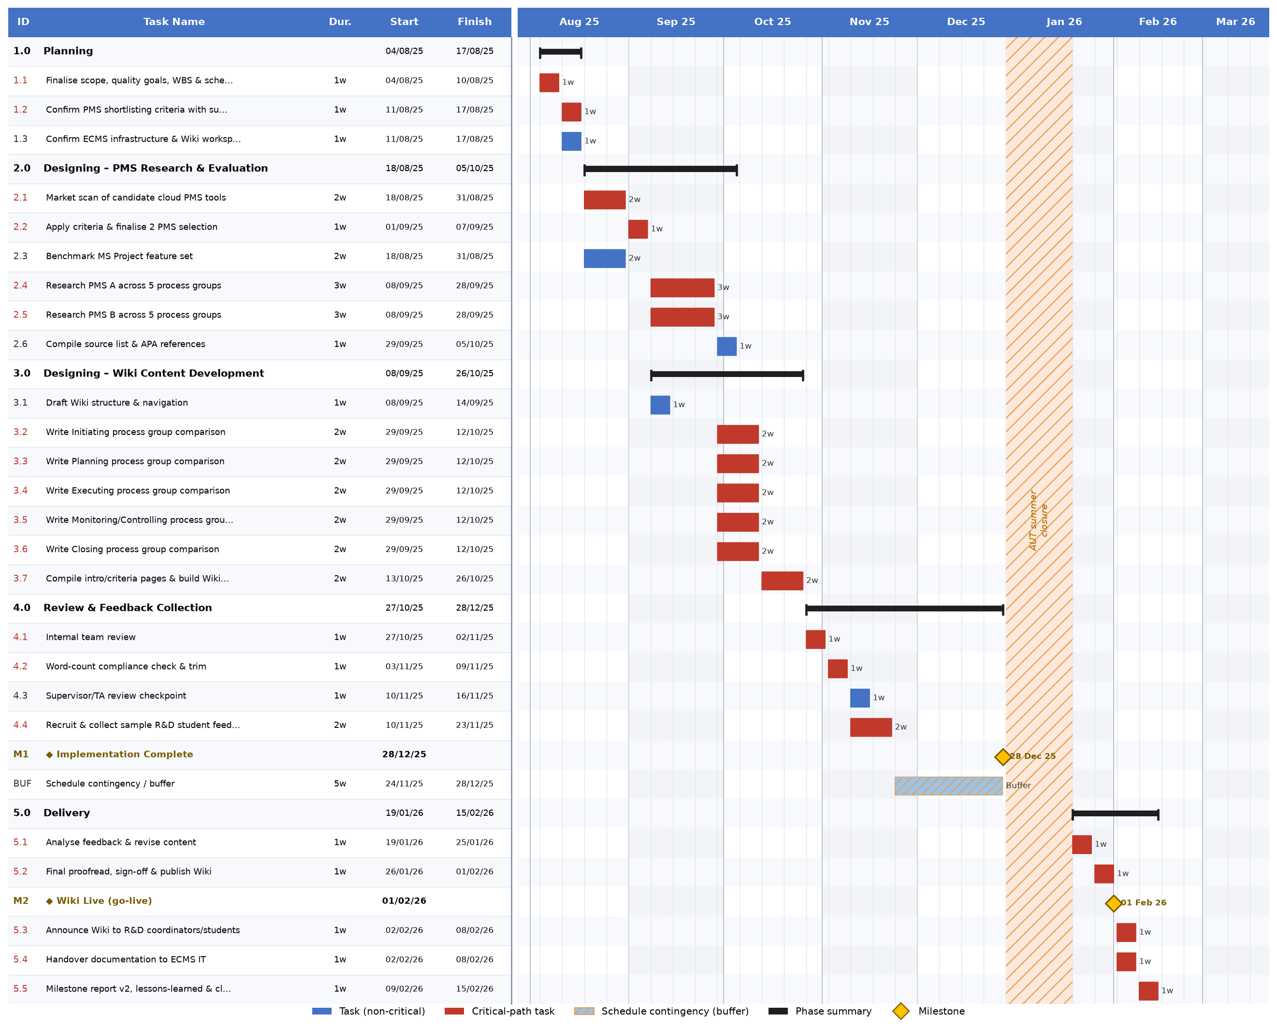

16b. Network Diagram
The diagram below is an Activity-on-Node (AON) network: each box is a work package, arrows show dependency, and boxes stacked in the same column can run concurrently because different people own them. Red-bordered boxes are the critical path (zero float, a delay to any one of them delays the whole project by the same amount); grey boxes carry float; gold boxes are milestones M1 and M2 are added phase-completion milestones (end of PMS Research & Evaluation, end of Wiki Content Drafting) used for progress tracking; M3 and M4 are the two brief-mandated milestones from the Business Case (Implementation Complete, Wiki Live).
Figure 2 – Network diagram (Activity-on-Node), critical path highlighted
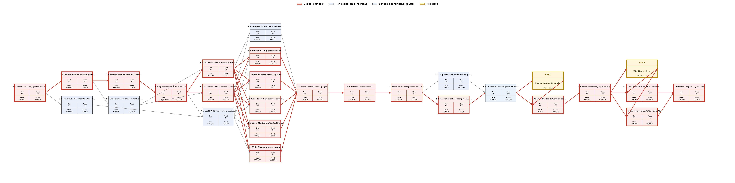

16c. Critical Path Analysis
Project duration: 25 working weeks of team effort (28 calendar weeks including the 5-week contingency buffer and the 3-week AUT closure), running from Monday 4 August 2025 to Sunday 15 February 2026, with the Wiki Live milestone landing on 1 February 2026 exactly the date the Business Case committed to.
Critical path: 1.1 → 1.2 → 2.1 → 2.2 → 2.4 → 2.5 → 3.2 → 3.3 → 3.4 → 3.5 → 3.6 → 3.7 → 4.1 → 4.2 → 4.4 → BUF → 5.1 → 5.2 → 5.3 → 5.4 → 5.5
20 of the 25 work packages sit on this path. A reminder that in a mostly sequential, small-team project, "critical" doesn’t mean rare. Only five work packages carry float:
WBS # | Work Package | Float | What the float means in practice
1.3 | Confirm infrastructure access | 5 wks | Can slip almost the whole planning phase without touching the schedule – low risk, can be delegated and checked on later
2.3 | Benchmark MS Project | 1 wk | One week of slack; useful if the same person is also on 2.1
2.6 | Compile references | 1 wk | Can finish up to a week after 2.4/2.5 without delaying 3.7
3.1 | Draft Wiki structure | 2 wks | Most slack of the "designing" packages – can be refined while research is still running
4.3 | Supervisor review | 1 wk | If the supervisor is slow to respond, one week is absorbed before it threatens the buffer

Effect of changes on project completion
Because float is zero along the whole critical chain, each of those 20 work packages has a single valid start/finish window the Start/Finish columns in §16a are simultaneously the early and late dates. There is no room to start any of them later than shown without pushing every downstream date back by the same amount.
The 5-week contingency buffer is the only true slack in the project, and it sits deliberately before Implementation Complete rather than scattered across individual tasks. A slip anywhere in Phases 1–4 (1.1 through 4.4) eats into that buffer first e.g. if PMS vendor pricing changes mid-research and 2.4/2.5 run a week over, Implementation Complete still lands on 30 Dec 2025, just with 4 weeks of buffer left instead of 5. If cumulative delays exceed 5 weeks, the buffer is fully consumed and Implementation Complete itself slips.
Once the team resumes after the AUT closure (19 Jan 2026), there is no float left anywhere. 5.1 and 5.2 sit on a hard, unbuffered 2-week countdown to go-live. A one-week delay to either a slow round of feedback revisions, a publishing hiccup pushes Wiki Live past 1 February 2026, the date the whole project exists to hit (R&D teams need the Wiki before Semester 1, 2026 begins). This is the single highest-risk point in the schedule and the one worth flagging explicitly to the supervisor.
5.3 and 5.4 run in parallel after go-live and don’t depend on each other, so neither creates a secondary bottleneck but 5.5 can’t start until both finish, so a delay to either one still delays project closure.

Sources
- Project facts (budget, dates, team, approach): Business Case & Project Charter, Assignment 1 Part 1.
- Brief requirements for items 15/16: Assignment 1_S2_2026.pdf, p.4.
- Method: PMBOK-aligned Work Breakdown Structure and Critical Path Method (forward/backward pass), as covered in the COMP507 Schedule Management lecture material.

